**Proefjes voor thuis**

**[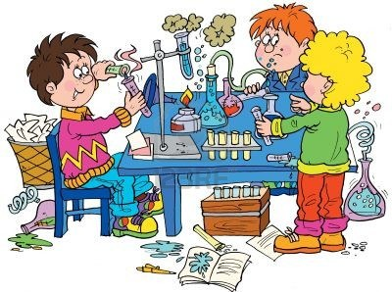](https://www.google.nl/url?sa=i&url=http%3A%2F%2Fchemie.vermaseren.nl%2F&psig=AOvVaw0Wgs8ZD7ylLa5kRLGvVPO2&ust=1585302483758000&source=images&cd=vfe&ved=0CAIQjRxqFwoTCKDVqJPut-gCFQAAAAAdAAAAABAO) Instructiekaarten**

[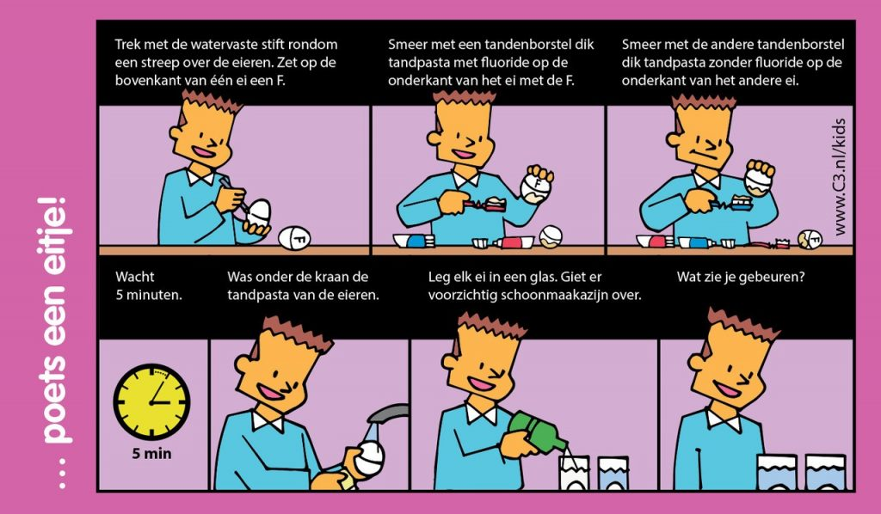](https://www.expeditionchemistry.nl/proef-poets-een-eitje/poets-een-eitje/)

[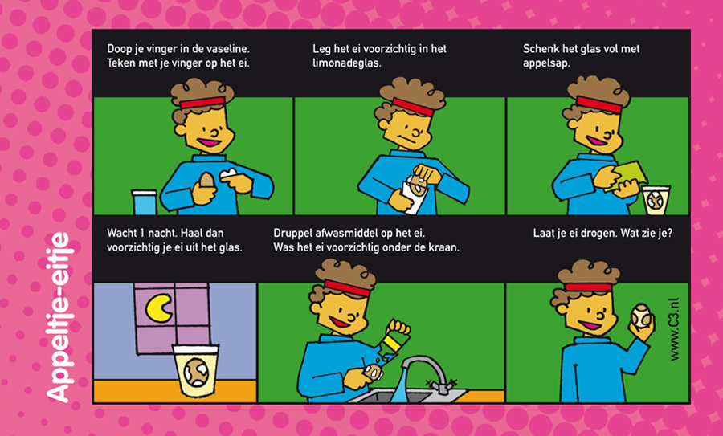](https://www.expeditionchemistry.nl/wp-content/uploads/2013/01/proefjeAppeleitje.jpg)

[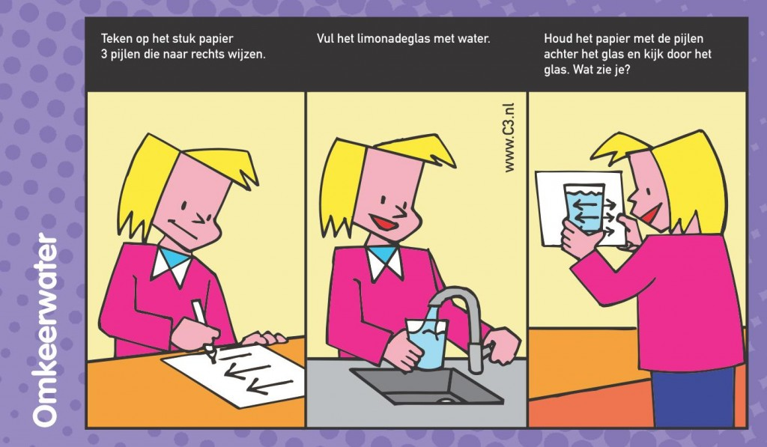](https://www.expeditionchemistry.nl/wp-content/uploads/2013/11/waaier2013C3-def_04.jpg)

[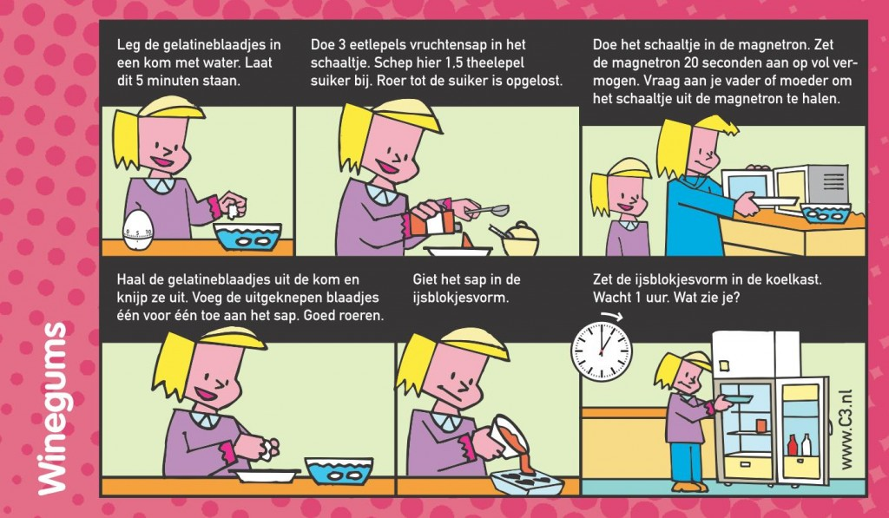](https://www.expeditionchemistry.nl/wp-content/uploads/2013/11/waaier2013C3-def_09.jpg)

[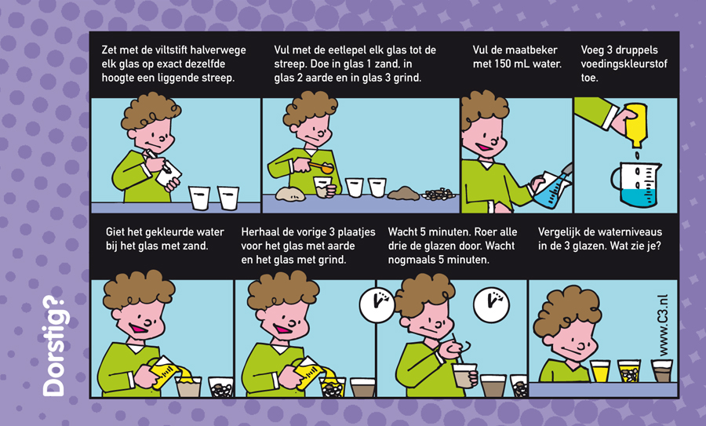](https://www.expeditionchemistry.nl/wp-content/uploads/2013/01/proefjeDorstig.jpg)

[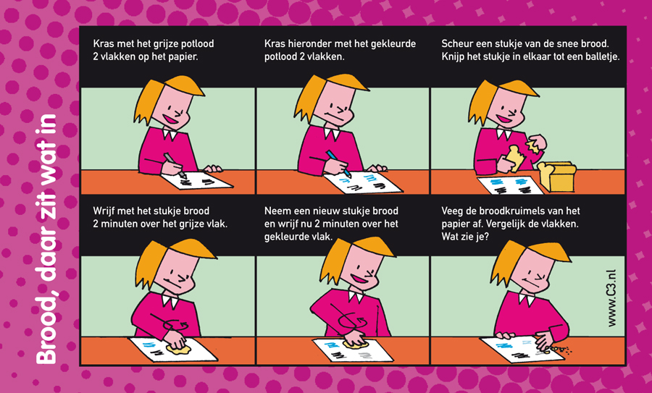](https://www.expeditionchemistry.nl/wp-content/uploads/2013/01/proefjeBrooddaarzitwatin.jpg)

[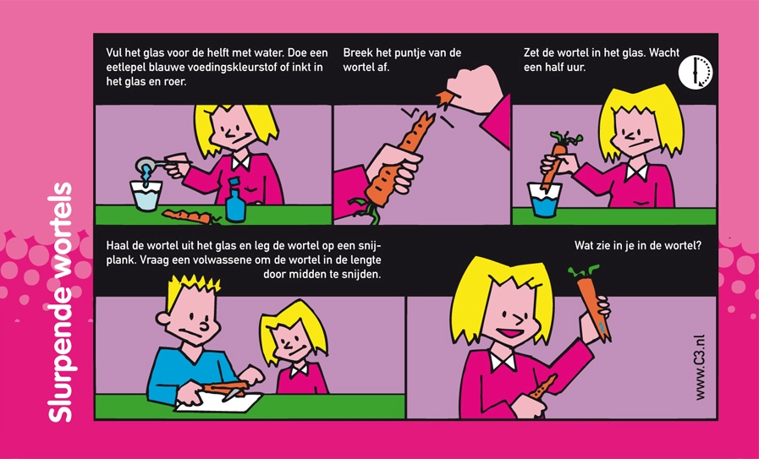](https://www.expeditionchemistry.nl/wp-content/uploads/2012/01/proefjeSlurpendewortels1.jpg)

[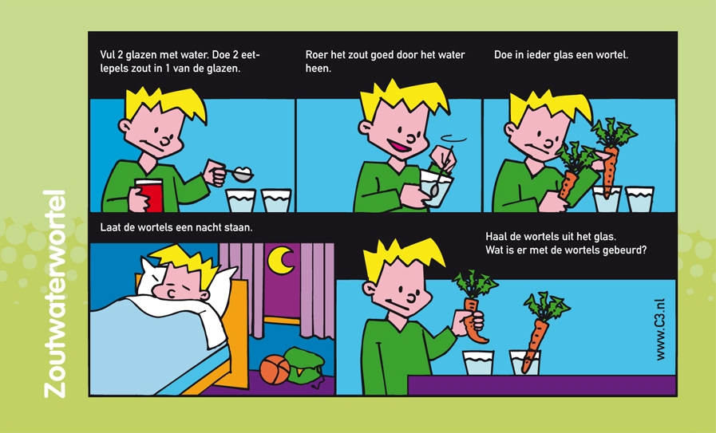](https://www.expeditionchemistry.nl/wp-content/uploads/2012/01/proefjeZoutwaterwortel1.jpg)

[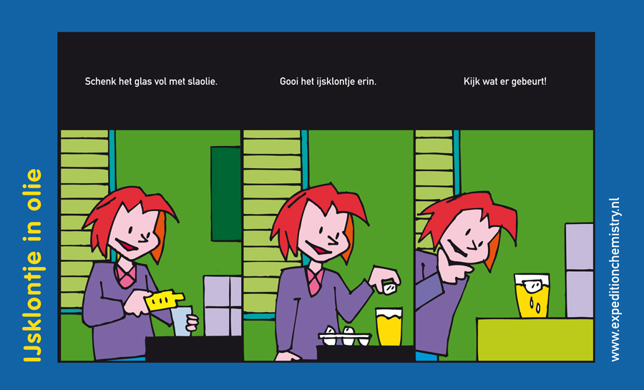](https://www.expeditionchemistry.nl/wp-content/uploads/2010/12/ijsklontjeinolie.jpg)

[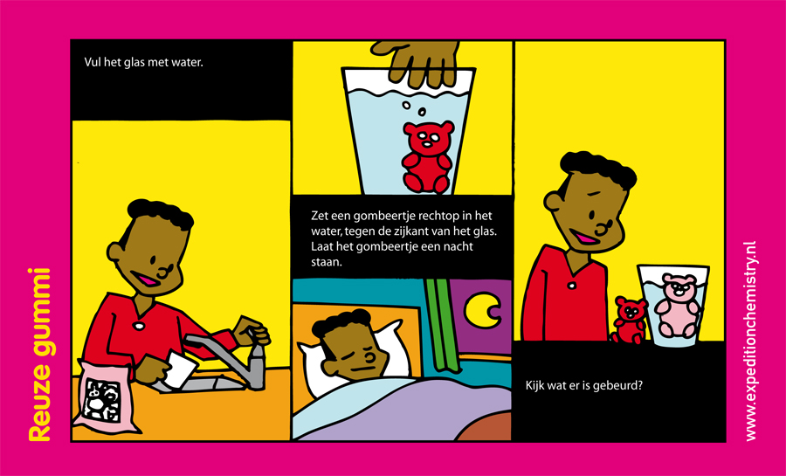](https://www.expeditionchemistry.nl/wp-content/uploads/2010/12/reuzegummi.jpg)

[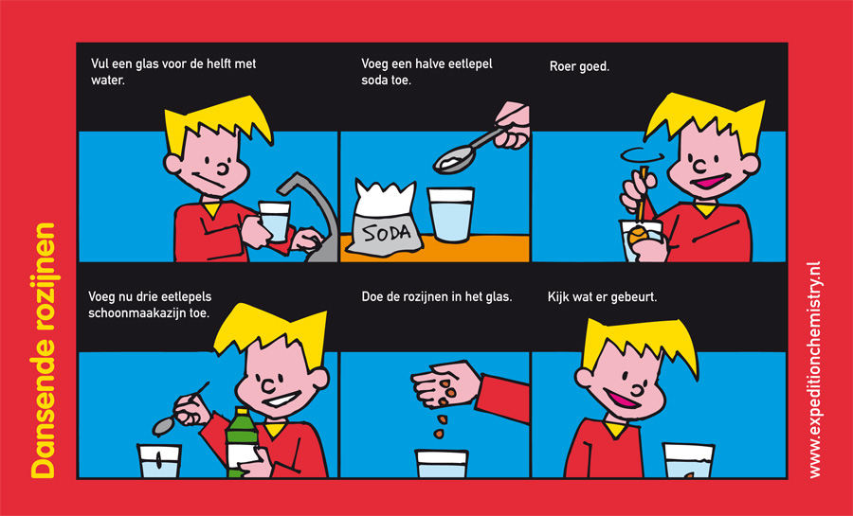](https://www.expeditionchemistry.nl/wp-content/uploads/2010/10/dansenderozijnen.jpg)

